The Great Temple Terrace at Urkesh

and the Lions of Tish-atal

The 18th Season of Excavations at Tell Mozan

for SCCNH (Owen Volume) – December 2005

Giorgio Buccellati and Marilyn Kelly-Buccellati

The Temple and its Terrace

The main goals
During the 2005 season, excavations at Tell Mozan were concentrated exclusively on the Temple Terrace and the Plaza in front of it – for several reasons. (1) We had concluded during the 2004 season that the Mittani period strata (1500-1350 B.C.) were more important than we had expected, because they demonstrated the continued significance of the Temple as a Hurrian religious center. The buildings to the west were not rural village houses, but rather a service center for the functioning of the Temple. What was, then, the nature and extent of the Mittani period Temple and Temple Terrace system which seemed to be the only reason for the continued existence of Urkesh?
(2) We knew that the Terrace and its perimetral wall dated to an early period, on account of the fact that the Temple at the top (which we excavated in 1984-1986) dated to about 2400 B.C. However, all the strata associated with the wall itself, excavated last year, dated to the Mittani period. Where were the third millennium strata?
(3) The very monumental nature of the Temple Terrace and its excellent preservation recommended that we make a full scale effort to expose as much of it as possible, in order to enhance the fruition of this structure so unique in the Syro-Mesopotamian landscape of the third millennium. Possible plans were drawn up envisaging the use of mechanical means to remove the inert sedimentation that had accumulated over the centuries on top of the plaza fronting the great terrace. For a number of reasons this was not pursued, although we think it should remain an option for the future. But even the limited exposure that could be obtained with normal manual excavations was sufficient to achieve all three of our main goals.
(4) The chronological sequence is particularly important in view of three considerations. () The Ninevite V date proposed by our German colleagues at a rather higher elevation is at variance with the results of last year’s excavations, which showed that the top three meters of deposition are all to be dated in the Mittani period. () We assume that the deposit in front of the Terrace Wall would be much thicker in second millennium than in the third, on account of the fact that the plaza itself would have been open to the south in the third millennium, but would have been blocked in the second – resulting in the formation of a basin that would trap the sediments flowing down from the Terrace. () We hope to establish a good typological correlation with the Tupkish Palace, since our ultimate goal is to link that Palace with the Temple and to study the central public urban landscape of the city.
In this article, we will present the results of the most recent excavations and will draw some conclusions that seem to us particularly important in function of a better understanding of the most ancient history of the Hurrians and of their presence in northern Syria, embodying a fully developed urban culture at a much earlier period than universally assumed. It gives us special pleasure to be able to offer these considerations in honor of David Owen, a friend and colleague who has centered much of his attention on the very nature of Hurrian civilization and has been so warmly forthcoming with his knowledge and supportive of our own work along these lines.

History of the research
Excavations of Temple BA began on the very first day of our first season, in 1984, and continued until 1987. Being very near the surface, it was surprising to find that the earliest phase, and the only one that could still be fully exposed, dated to late ED III. This has remained to-date the largest exposure of any structure at Tell Mozan belonging to this phase, which (termed Phase 1) has been applied also to the pre-palace remains.
Given the early date for the Temple, and its high elevation (9700); given the otherwise substantial presence of second millennium material in the rest of the High Mound; and given finally the extreme paucity of ceramic material in the flat area to the south of the Temple (to which we had assigned the label J) – we had anticipated that the Temple had originally been built on a central artificial rise, which came successively to be ringed by other, later, rises, and that the sterile zone J to the south represented some kind of open area.
In order to continue with the exploration of other parts of the mound, it was decided not to continue excavations in the area of the Temple, and in 1990 we opened a new excavation area (AA) in the mid-western part of the Tell. Its original purpose was to develop a stepped trench that would link a flat open area at the base of the tell with what appeared to be the latest phase of occupation at the top. In the process, we uncovered the royal Palace of Tupkish, which was subsequently found to expand eastward in the direction of the Plaza. It thus appeared that we had a single monumental urban complex that included the Palace with the sacral area of the ābi to the west and the Temple with its Terrace to the east, joined in the middle by the Plaza J. Hence the decision to devote the 2005 (and 2006) seasons entirely to the goal of linking together as much as possible the various components of this complex, and in particular to clarify the nature and extent of the Temple Terrace.
Our anticipation about an artificial rise supporting the Temple found its first confirmation when we planned for excavations in area C2, which were to begin in 1999 as joint field work with Peter Pfälzner and Heike Dohmann-Pfälzner and their team from the Deutsche Orient-Gesellschaft and the University of Tübingen. In order to establish a stratigraphic link with the area of the Temple, it was decided that C2 would be linked through a long trench (B6) with the excavations of Temple BA, and in so doing, it was found that the rise on which the Temple stood was ringed by a stone wall and that a monumental staircase gave access to the Terrace and the Temple. The perimeter of the wall was further investigated by means of a geophysical survey, organized by the Pfälzners, which revealed the presence of a continuous line in the form an oval. The geo-physical investigation also confirmed our initial supposition (based on the extreme paucity of ceramic material) that zone J in front of the Terrace was an open area, devoid of structures.

The 2005 season
The 2005 season lasted from July 26 to September 19. The staff included, besides the writers, Federico Buccellati, Patrizia Camatta, Sarah Comelli, Rasha Endari, Jean Evans, Giuseppe Gallacci, Minna Haapanen, Antonio Landi, Giada Minisini, Jamal Omar, Willliam Orrange, Barbara Pritzkat, Valentina Santi, Mary Stancavage, Carmen Valdes Pereiro, Vincent Van Exel, Jim Walker. We also had working visits by Ioanna Kakoulli and Christian Fischer from UCLA, Paola Pesaresi as architect, Joan Aruz, Curator of the Ancient Near East at the Metropolitan Museum of New York.
We must record the tragic event that occurred at Tell Barri on August 29, which resulted in the death of our great friend and colleague, Paolo Emilio Pecorella. His loss affected us deeply, and will leave a permanent void in the scholarly landscape of the region.
On September 8 we were privileged to host a visit by his Excellency the Minister of Culture, Dr. Mahmoud Alssayed, accompanied by Dr. Bassam Jammous, Director General of Antiquities and Museums, Dr. Ahmad Seriyeh, Director of Museums, Eng. Elias Botros, Director of Historical Monuments, Mr. Abd el-Mesiah Bakdou, Director of the Hassaka Office of the Directorate. On that occasion, all directors of the Expeditions working in the Jezirah were invited for a meeting and a dinner with the Minister. As always, we are grateful to the Syrian authorities who facilitated in every possible way our continued work at the site.
Funding for the 2005 season of excavations came from the Catholic Biblical Association, the Samuel H. Kress Foundation, the Cotsen Institute of Archaeology at UCLA, and from IIMAS – The International Institute for Mesopotamian Area Studies. Funding for preparation of the publication in the shape of the Global Record came from the Committee on Research of the Academic Senate, UCLA, from the Von Grunebaum Center for Near Eastern Studies, UCLA, and from Mr. Lloyd Cotsen.

Development and structural components
As a result of the work conducted in the 2005 season we now have a good understanding not only of the stratigraphic history (discussed in section 2), but also of the structural composition of the Terrace (discussed in sections 3-5). By way of introduction, we will highlight here the major conclusions of our analysis.
The Terrace consists of five major components (see Fig. 8.1). (1) At its base, a fairly steep escarpment bridged a difference in elevation of about 2 meters between the level of the Plaza and the base of a stone wall that ringed the Terrace. (2) An inner core (not excavated, but only inferred) represents the earlier Terrace, accessed by a similarly earlier version of the monumental staircase. (3) A packing was placed on top of the inner core to raise the top level of the Terrace. This formed a glacis the top surface of which was covered with a water resistant coating and (at least in part) with mudbrick. Concentric rings of small boulders were located along the surface of the glacis. (4) A revetment wall lined the outer face of the Terrace. In a minor way it served the function of a retaining wall, but only for the limited amount of packing contained between the inner core and the revetment wall itself. (5) A monumental access to the south consisted of a central staircase flanked by two trapezoidal aprons that widened towards the bottom.
The Temple and its Terrace were constructed in their present form between 2400 and 2350 B.C. The escarpment and the revetment wall remained unobstructed for a number of centuries. The situation began to change in the Khabur period, probably around 1800 B.C. It is at that time that we assume the Plaza began to be blocked on its southern side by new constructions that impeded the water flow coming from the Temple Terrace. As a result, a semi-natural sedimentation began to cover the floor of the Plaza – semi-natural because while the process was due primarily to natural forces, the inclusions contained ceramic and other material. The Khabur period sedimentation would have covered the Plaza to a level slightly below the top of the escarpment (not reached as yet in the excavations), at which point the Mittani layers begin, which continue unabated for an additional 3 meters, to where they reach the top of the wall.
We have good reasons to believe that the revetment wall as originally constructed remained in use, without damage or encroachment, for some 900 years, until about 1500 B.C.. At that point in time, the wall continued in use, and still without damage, but the growing natural sedimentation above the Plaza began to cover its face, until it completely hid it from view by the time the site was abandoned, about 1350 B.C. At the end of this process, when both the revetment wall and the staircase had been largely so covered, a new and larger frame was built (or restructured) for the top part of the staircase. Thus we date to the latest phase, about 1400 B.C., the widening of the apron and the slight reorganization of the staircase itself.
There must already have been a considerable rise that predated the Terrace, in function of an earlier version of Terrace and Temple. The only direct evidence for this is the presence, at the base of the exposed staircase, of stone steps that underlie the staircase itself. A second argument, strongly (if indirectly) pointing in the same direction, is the fact that the base of the Terrace as preserved is at elevation 8700, about 12 meters above the ancient level of the plain, which, it can be argued, did not rest in turn on an original natural hill, but only on an artificial rise. (The main reason is the existence of cultural levels at the elevation of virgin soil too near to the central part of the inner core to allow for any natural rise.) It seems therefore inescapable that this artificial rise, with its stone steps in the same location as the later staircase, would have been in function of a Temple of which the one we have excavated would be the direct heir. While this earlier Temple may date to early ED III, it seems only plausible that earlier versions yet would have been present, dating possibly back all the way to the beginning of the third millennium.
There are good circumstantial reasons to believe that the Temple with its Terrace, built in its present form around 2400 B.C. but with antecedents most likely going back several centuries, was dedicated to Kumarbi (see below, 7.1), the main ancestral god of the Hurrian pantheon. If so, we come here in touch with one of the most archaic and most pristine monuments of Hurrian religion and ethnicity.
This is all the more remarkable if one considers that the great underground structure, identified as a Hurrian ābi, exhibits a parallel history. The earliest levels we have excavated so far date to Phase 1, i.e. to late ED III, but we have not reached the bottom of the structure. One must note that the current elevation of the lowest point in the ābi is about 6 m. above virgin soil, and that the later levels point to a remarkable stratigraphic continuity. Thus it seems more than likely that the ābi, too, should give evidence of a much earlier tradition, possibly going back to the beginning of the settlement at the start of the third millennium. The profoundly Hurrian nature of the structure would then be matched by that of the high Terrace and Temple, and together they present us with a monumental complex that is as impressive ideologically as it is architecturally.

Stratigraphy

Strategy
The major stratigraphic aims were to (1) open two windows along the southern face of the perimetral wall, intending to reach elevation 8500 (the surface being in this area at an elevation of around 9200); (2) open a sounding on the inside of the wall to ascertain the nature of the Terrace core; (3) follow the staircase to determine what might lie at its base; (4) establish a clear chronological sequence from the accumulations against the perimetral wall.
The lowermost elevation of 8500 was suggested as a target by the fact that this is the elevation of the large paved stone courtyard in the Tupkish Palace, and is also the elevation of the brickfall that we assume to be that of the eastern perimetral wall of the same Palace (in A19, see Fig. 8.2). It seems plausible that the level of the plaza JP, adjacent to the Palace, should be at this approximate elevation. Consequently, we hypothesized that the perimeter wall of the Temple Terrace, bounding the plaza on the east as the palace does to the west, should also be founded at approximately the same elevation.
Accordingly, we worked in three excavation units (Fig. 8.3; Ill. 9.1). In J1 we meant to reach the bottom of the wall and to explore the nature of its articulation: could one find evidence of a buttress or a tower? does the wall define an oval or a polygon? is there an additional staircase to the west?
In J2 we planned to expose the southwestern end of the stairway complex and reach its foundation, assuming that this, too, might be at elevation 8500 and we expected thereby to reach the base of the wall.
In J3 we wanted to clear a small portion of the inside face of the wall, in order to gain insight into the construction techniques of both the wall and the terracing. We further planned for an additional sounding at some distance to the south of the face of the wall, with the aim of verifying the nature of what we assumed to be the inert sedimentation.
In addition, we also intended to experiment with a new kind of step-and-slope section proposed by architect Gionata Rizzi. While common in non-archaeological engineering work, this type of section has not been used, to our knowledge, in archaeological field work in our general region. The two main reasons for such a change in the time-honored tradition of straight archaeological sections were security for the visitors, and protection against erosion.

Phase assignments: synopsis
The number sequence in phase and strata assignment differs from area to area. The following synoptic chart will help in visualizing the correlation among them.
Temple BA |  | Plaza and Palace AP  (including AK) |  | Area C2 | Mesopotamian periods | Tell Chuera
phase | ruler | phase | ruler | stratum | Mesopotamian periods | Tell Chuera
3 | Atal-shen (?) | 4b |  | 6 | Isin-Larsa | -
2 | Atal-shen (?) | 4a |  | 7 | Ur III | -
- | Tish-atal (?) | 3b | Ishar-kīnum |  | post-imperial Akkadian | Ie
- | Tish-atal (?) | 3a | Tar’am-Agade | 8-11 | imperial Akkadian | Ie
- | Tish-atal (?) | 2 | Tupkish | 12 | imperial Akkadian | Ie
1b | Tish-atal (?) | 1 |  | 13-16 | early Akkadian | Id
1a |  |  |  |  | late EDIII | Ic

Evidence for the period before 2400 B.C.
The general elevation of the Temple Terrace is high: the Temple floor (dating to about 2400 B.C.) is at 9700, i.e., some 22 meters above virgin soil which is at about 7500. Such a high elevation for such an early date had suggested to us when we first excavated the Temple that it stood above layers that were considerably earlier in date or that it stood on a massive artificial fill. We can exclude a natural hill situated under the Temple since a sounding nearby that reached virgin soil indicated an elevation for virgin soil that was constant with the surrounding plain. As a result of the recent excavations, we can now point, for the first time, to positive stratigraphic evidence in support of the same conclusion. This evidence comes from two locations.
(1) At the base of the staircase in J2 there are steps and pavements that underlie the major staircase, thus indicating the presence of an earlier structure with similar features. And (2) in the accumulations that underlie the top surface of the Terrace, and are faced by the revetment wall, there is ceramic material that can be dated to the Chalcolithic period (see below, 6.5, for a brief typological discussion). Given the way in which we can assume the terracing was built (3.4), it is clear that this material was brought in from an original context at another location, presumably a Chalcolithic settlement in the area of what later became the lower city.

Construction of wall and staircase about 2400 B.C.
The date for the construction of both the wall and the staircase is made certain by the nature of the accumulations that abut their base in J1 and J2. Typologically, the ceramics from the layers that abut the lowest 50 cms or so of the wall belong to Phase 1 (see above, 2.2, for the phase sequence, and below, 6.4, for the typology).
The key stratigraphic consideration is that these accumulations clearly abut the base of the wall, and therefore conclusively date the moment of construction. The situation is clearly visible in Ill. 9.4 for J1, and Ill. 9.3 for J2.
In Ill. 9.3 another important stratigraphic detail must be noted. The accumulations that are dated typologically to Phase 1 abut not only the revetment wall, but also the side wall of the monumental staircase. As a result, it is also beyond doubt that the lower part of the staircase (the one that is flanked by the side wall) dates to Phase 1 as well.
This conclusion rests on the further inference that the revetment wall, the side wall and the lower staircase, all exhibit a structural coherence that justifies considering them as having been set in place at one single time, without successive patching or rebuilding of the lower portion of the structure.

Structural integrity of revetment wall and glacis
through 1400 B.C.
Excavations in J3 led to a significant conclusion regarding the date of the packing, and hence of the top of the wall as preserved. We were in fact able to determine that the top of the wall as we have it today is in all likelihood the same as originally constructed in the third millennium. Our conclusion is based on the fact that we have, in J3, the top of the original Terrace, dated by pottery contained inside a 30 to 50 cms layer of baqaya that coats and seals the top of the Terrace. The baqaya coating of the glacis is such a major engineering work, and is so clearly integrated with the inside coating of the revetment wall, that it stands to reason to assume that it is the original top of the Terrace. And since it joins neatly with the top of the revetment wall, it is also logical to assume that the top of the wall as we have it dates to the same period.
This is a significant conclusion, because it implies that (a) the state of preservation is well nigh perfect, and that (b) the revetment wall stood the test of time for some 900 years both structurally and in terms of not being damaged or altered by any later intervention.

The gap between 2400 B.C. and 1500 B.C.
The immediate superposition of mid second above mid third millennium material is puzzling at first – especially since we have deposits of that period some 7 m thick to the west, in the area of the Palace. Why is it that we have in front of the Temple Terrace no evidence of material contemporary with the Palace, which dates to a period of great importance for Urkesh?
The answer can be gauged from the stratigraphic situation as summarized in Figs. 8.6 and 8.7. When first built, the Temple Terrace wall rose to a height of 3 m above a high glacis which was probably 2 m above the plaza. From the level of the plaza at the base of the glacis (elevation 8500) up to the floor of the Temple (elevation 9700) there was a difference in elevation of some 12 meters. The plaza was open to the south, so that there was room for the run off water to flow down to the surrounding plain. In the second millennium, however, the plaza began to be blocked to the south by new constructions, and sedimentation began to occur above the plaza. The lower levels were at the base of the glacis, and only as the sedimentation grew did it reach as far as the base of the wall – where we have found it laying directly upon the earlier floors. We expect that future excavations will follow the slope of the escarpment down to the surface of the plaza and uncover Khabur period strata.

The re-organization of the space around 1500 B.C.
The stone staircase in J2, with its monumental frame that we had exposed last year, continued in use during the second millennium, and in particular in Mittani times (see section 6.2). There is a possibility that the top half, with its wider secondary apron, may have been built, or at least rebuilt, at that point in time.
There are two main reasons for this tentative suggestion. The first is that in J3, where we have exposed the extreme western end of the apron (see Ill. …), we could determine that the pottery found in the layers immediately under this portion of the apron is also from the Mittani period. This does therefore provide a terminus post quem for at least this portion of the apron. But it is, of course, possible that the apron may have been repaired in later times, in which case the evidence from the pottery underlying its extreme western end would be inconclusive.
A second reason to assume that a major reorganization of the monumental staircase may have taken place in the second millennium is also tentative – namely that there are clear discontinuities between the lower and the upper part of the staircase (see Ill. …). In the staircase itself, the stone of the steps is more accurately hewn and the height of the steps is more regular than in the upper part. In the upper part, the reverse is true, and the apron, too, shows irregularities that may not occur in the lower part. At this same point, i. e., half way up the main apron, where the discontinuity is more apparent, we have a large stone placed so that it may have served as an offering table or a type of ritual platform. As noted below (section 3.5), the use areas seem to have been shrinking progressively with the passing of time, and the major reduction seems to have coincided with the major discontinuity just noted, which we consider the main transitional moment between phase 6a and 6b.
Another aspect that may have coincided with this transition in the phases is the progressive disappearance of the revetment wall in its western portion (this is shown in the two sketches given as Figs. … and …). The top of the third millennium wall was lower in J1 and J3, and it may be that in J2 the higher portions are linked with the restructuring that occurred within phase 6.

The second millennium inert sedimentation above the plaza
As already shown by our earlier excavations, the area in front of the Terrace wall consists exclusively of a very regular layering resulting from natural sedimentation – the only exception being the use areas immediately adjacent to the monumental access area in J2 (see below, section 5.2). This is clearly evidenced by the long sequence of strata in all three units that are evenly horizontal in their alignment, without any intrusions (such as pits or tannurs), and which consist of a uniform grey matrix, with small pebbles and sherds as inclusions. These strata abut the great Terrace Wall, and show that the wall continued, throughout Mittani times, to be exposed, and respected (since there is no evidence of any stones having been removed).
At a depth of about 2 m in squares J1k7 and J3k103, the sedimentation becomes so hard that even the big pick bounces back as if used against a stone. As a test, we have used a jackhammer for one day. This did indeed help, in that it served to break down the hard layer that was almost impervious. We monitored closely the use of this tool, new for us, and we felt that in the right situation and under proper supervision it may indeed serve a very useful purpose.
As already noted in our 2004 excavations in J1 and J2, there are large boulders that are found just above and near the top of the face of the great Terrace Wall. By all indications, these boulders do not come from the wall itself, since the top line of stones in the wall is preserved to a uniform height. We assume that they came instead from two (or more?) concentric stone loops that ringed the Terrace at two (or more?) distinct levels on the upward slope towards the Temple (see Fig. 8.1). These stones would easily have slid down along the relatively steep slope, and they would have stopped in some cases at the top of the wall, while in other cases they would have rolled over the top portion of the wall as it was still showing. Illustration … shows a good view of this situation.
The tumbled boulders are found only in the uppermost Mittani strata, i.e., in phase 6b. This is indicative of a moment when the Terrace begins to lose its identity as a high profile structure, clearly marked by a high wall rising above the rest of the site. It had become, instead, a gentle rise barely marked by stone loops that were losing their full significance. As the stones began to slide down the slope, nothing was done to prevent that from happening, and yet the space was still sufficiently privileged to prevent the rolled stones from being removed and used for other purposes. In the earlier phase 6a, on the other hand, the Terrace had retained its marked identity since the top of the wall was still showing to a height of a couple of meters, and thus the Terrace slope itself retained its identity, and the stone loops were maintained – so that as a result we do not have tumbled stones in the lower strata of phase 6a. This situation is illustrated in the sketch given as Fig. 8.1).

Scattered occupation after the end of Urkesh as sacral center
In the topmost layers of J3 we have found a tannur, and three more tannurs had been found last year in the same topmost layers in J2. We consider them now evidence of what we have been calling scattered occupation, i.e., a sparsely inhabited settlement, at a time when the sacral use of the great Temple has ended, so that non-sacral uses (such as occasional baking of bread) may occur at the very center of what had been the very sacred, and hence inviolable, Temple Terrace. In J3, it is clear that the tannur overlays the strata where the wall is still visible and untouched (hence functionally operative), even if greatly reduced in size (Ill. …)
We have accordingly introduced a new phase, 7, that reflects precisely this final moment in the occupational history of Urkesh. We consider it to correspond to the period when the identity of the site as a specifically Hurrian religious center had waned, so that this scattered occupation would reflect the transition to Assyrian times.

The Terrace: revetment wall, packing and glacis

The base of the Terrace revetment wall and its structural features
The base of the Temple Terrace wall is clearly visible in J1. Though exposed only to a width of some 2 m., there is no reason to believe that the situation would be any different at other locations.
It is at elevation 8700, i.e., about 2 m higher than the expected 8500 – but the escarpment in front of the wall (see presently) would have bridged the difference in elevation.
Several structural elements must be noted. First, there are no foundations to the wall. As shown clearly by the excavations in J1, there is no trace of a foundation trench in the sections, and the escarpment abuts the very base of the wall, its top being only about 20 cms above the bottom of the lowermost stones.
Second, the wall is of limited width, a little over one meter, about the width of two large stones placed side by side. The stones are irregular in shape, and are set in a plain mud mortar.
Third, the face of the wall shows no dsicernible batter , nor is there any evidence for buttresses, pilasters or towers (though of course the possibility remains that such may be found when further excavations will expose larger portions of the wall). The face of the wall itself is coarse, meaning that there is no alignment of flat faces of the stones and that the joints are quite uneven.
Finally, the wall is of limited height, about 3 meters or slightly more as one approaches the great staircase.
It cannot therefore be considered a retaining wall, since, given the structural characteristics just mentioned, it would not easily withstand the internal outward pressure coming from the Terrace core. We may consider it instead a revetment wall built along the Terrace packing, as a protection against erosion and also for aesthetic reasons. The revetment wall would have been built at the same time that the packing was put in place (see below, 3.4).

The escarpment at the base of the wall
In J1 we have a clear surface that marks the top of an escarpment sloping down from the base of the revetment wall towards the south. In J2 we did not reach the top surface of the escarpment, but the alignment of the accumulations at a slightly higher elevation suggests a similar slope in what we presume to have been the same escarpment, in the same direction.
We assume that this escarpment rose to a height of about 2 m above the level of the plaza. The only reason for this assumption is the further assumption that the floor of the plaza JP was at elevation 8500 (see above, 2.1). One of the goals of the 2006 excavations will be to probe precisely this situation, following the slope of the escarpment down to the level of the plaza.

The inside face of the Terrace revetment wall
The major aim of the excavations in the J3 unit was to give us a view of the inside face of the wall. We wanted to determine the degree of structural stability of the wall in case we could in the future expose fully the wall. In so doing, we followed a suggestion made by Gionata Rizzi whom we had consulted with regard to the general advisability of exposing the Terrace wall.
The results were of great interest, and they confirm the conclusions based on the structural make-up of the wall, namely that what we have here is a revetment rather than a retaining wall (see above, 3.1).
As it turned out, the inside face of the wall presents a much smoother surface than the coarse outer face. It is coated with a reddish clay material with large limestone nodules that is still today very typical of house constructions in the area. It is called baqaya, which refers to what “remains” after gravel and large pebbles are extracted from the virgin soil. Today it is commonly used as subfloor material, and the local perception is that it serves to provide a water resistant layer that protects the floor from the humidity rising from the ground. Because of its use in our specific context, we will refer to it as “lining.”
A suggestion by our architect, Paola Pesaresi, points in a slightly different direction. It would make little sense to waterproof the inside of the revetment wall, since that would lead to the confluence of an excessive amount of water in a single spot so as to cause eventually a concentrated runoff that would burst the revetment wall. It seems more likely that the baqaya coating served rather as a filter that distributed evenly the water infiltrations, so that they would seep in equal amounts through the stones of the revetment wall. This shows great engineering sophistication, in that it allows the water, streaming down from the top of the Terrace, an even flow that would not cause breaches in the wall. We did bring back samples of this coating which are now being analyzed to test Pesaresis hypothesis.

The terrace packing and the glacis
A concomitant aim of the excavations in J3 was to reach a better understanding of the nature of the packing that supports the glacis. We expected that such an understanding would in turn give us an insight into the basic question of the stability of the wall.
Even though very limited in size (2x2 m at the top, to a maximum depth of 2.5 m), the excavations have given us some remarkable insights into the nature of the accumulation that made up the packing and the glacis.
The packing consists of largely horizontal layers, in the nature of an accumulation rather than of a dump. The ceramic material is of particular interest because it contains a large amount of chalcolithic sherds (see below, 6.5). We interpret this as resulting from the demolition of some late prehistoric portion of the settlement in the Outer City. Also, one human skeleton was found, not disturbed, but also not placed in a burial shaft and not accompanied by any offerings.
The assumption seems likely, though it cannot be easily tested, that packing and rows of stones in the revetment wall were laid contemporaneously, thus building up gradually the edge of the Terrace.
The top of the packing was coated with the same baqaya material that we found lining the inside of the revetment wall. This produced a very well demarcated surface, with an upward slope identical in orientation to that of the modern tell. Following this slope, we would reach exactly the threshold of the Phase 1 temple we excavated in 1984.
The baqaya layer reached an elevation just below the top of the stones of the revetment wall. In the material that overlays this layer, there are fragments of mudbrick, that are not set in place but are rather unevenly distributed. We interpret them as being the debris of the brick surface that we assume to have originally covered the baqaya glacis, as shown by the trench B6.

Footings and use areas at the base of the wall
Significantly, the area in front of the western apron in J2 shows a distinctive occupational history. Here we have use areas that became progressively more marked as the excavations proceed downwards.
In the first place, we found substantial accumulations with strong lenses of ash and charcoal. These suggest that some activity was taking place here that involved burning. The occasion may have been the preparation of sacrificial offerings, not unlike the situation in southern Mesopotamia where a so-called “kitchen” temple is found at the base of the ziggurat, i.e., an installation where offerings are prepared to be then brought to the top of the Temple Tower itself.
The second piece of evidence that we have consists of minor installations that we assume served to set off the area next to the revetment wall and the staircase from its immediate surroundings. In Phase 6b we have what appears to be an offering table and in Phase 6a we have several screen walls (two of them to the height of only one course of stones) that demarcate an area west of the staircase, enclosed on three sides (see Ill. 9.3, 9.4).
In area J1, too, we have curtain walls from the early Mittani period. But in addition, we also have a sizeable footing placed directly the base of the wall, as if a large bench. It is interesting to note, therefore, that while the top of the wall remained apparently untouched for about 1000 years, additions were made at its base. The function of this footing is not apparent. Was it meant to serve a structural function, protecting the base of the wall, as with damp courses (kisû in Akkadian) against the base of mudbrick walls? Or was it a bench related to the use of the curtain walls in front? Larger exposure than was possible this year, towards the south, would presumably help find an answer. But what is certain from the accumulations against this feature is that it is to be dated to the early Mittani period.

The monumental staircase

Structural considerations
Clearly the most monumental part of the whole complex is the staircase that allowed access, over twenty-four well preserved steps, from the plaza to the top of the Terrace and the Temple. This year’s excavations have confirmed the structural understanding of the monumental staircase as we had hypothesized it in 2004. Thus its component parts remain essentially the same as presented in last year’s report, except that much more of what was then a projection has now been verified through excavations. A minor addition is that at the base of the main apron’s side wall there is a long rough stone, laid vertically in a slightly oblique direction, that provides a front edge to the side wall. Also interesting is the fact that the rows of stone in the wall slope slightly downward in the same direction as the accumulations that we assume overlay the slope of the escarpment. So this wall, too, does not serve any retaining function, but is essentially a revetment wall for the side of the staircase.
A difference in this year’s reconstruction is that we interpret the space at the top of the staircase as the base for a platform rather than for a built-up structure – but for neither do we have any evidence, except the lack of stones and the presence of material that suggest the presence of mudbricks.
Because of the orientation of the various elements, and in particular because of the presence of a perfectly symmetrical western edge of the main apron (visible in the small sounding on the upper right ADD REF TO KITE PICTURE), we assume that what has been exposed so far is only half of the monumental access structure. If so, the full structure would look as in the architectural reconstruction given as Fig. 8.8). This full view of what we think is the entire structure with its massive access, the glacis and the high perimetral wall above it, leads us to think that it is one of the most impressive architectural achievements of ancient Syro-Mesopotamia, and certainly one of the best preserved.

The higher stages of the monumental access
and the vanishing perimetral wall
Immediately above the 2400 B.C. floors at the base of the revetment wall (in J1) we have a thick deposit dating to the very end of the occupation of the site, from 1500 B.C. to 1350 B.C. This means that when this period began, the full staircase was still in view, except for the bottom couple of steps. In other words, the monumental Terrace had remained in use for about 900 years, and was still fully functional when the Mittani period began. Such a degree of continuity, and of structural stability, is stunning. All the more so since the Temple at the top must, instead, have been rebuilt several times: the one we excavated in 1984 dates exclusively to the early phase (2400 B.C.)
As the sedimentation in the Plaza grew after 1500 B.C., the revetment wall that defined the perimeter of the Terrace came eventually to be entirely covered. As a result, the focal point of attention shifted more and more in a different direction. While in the original perception the Terrace, sharply defined by the perimetral wall, dominated the skyline and the perception of a visitor approaching from the south, in the new perception the focus was on the single point where a wider apron framed the reduced number of steps. The apron may or may not have been as wide in earlier times, but it certainly served in the Mittani phase to direct attention to this single remnant of the earlier more monumental Terrace.

The lower stages of the monumental access
The lower half of the staircase and the corresponding portion of the apron (dating to the same time period as the Temple at the top, about 2400 B.C.) are more regular in appearance than in the upper portion. It is possible that the irregularities in the upper portion are the result not of poorer craftsmanship in the original construction, but of poorer maintenance in the later periods. But as it is, the individual stones of the lower portion are more symmetrical and uniform as to dimensions and are set more evenly in place. In particular, the correlation of two steps in the staircase for each row of stones in the apron is more orderly and proportional.
The vertical stone that leans obliquely against the front edge of the side wall of the apron provides a coarse but well defined frame at the base of the staircase, as if serving the function of a rough orthostat.

Projections
As we attempt to project what the full appearance of the Terrace Temple may have been like, two major possibilities may be envisaged: that the staircase as we have it now is but half of the fuller monumental access, and that there may have been a second staircase, perhaps to the west. Given the excellent state of preservation, it seems certain that future excavations may give a conclusive answer to these two possibilities – which we are entertaining at this stage of our work inasmuch as they condition our strategy for the future.
The wider dimensions of the southern monumental staircase are suggested by two considerations. First, we do have, in a small sounding that was first opened as part of B6, a symmetrical counterpart in the east to the top of the main apron in the west. By projecting this line to the south, we obtain a very regular geometrical figure that may be exactly what was intended by the original architect. This was the projection we already suggested in last year’s reconstruction. What became clear this year is that the staircase itself, as framed by the two aprons, presents a narrower trapezoidal, or even triangular looking, shape (Pesaresi was the first one to notice this).
The wall that appears only in the eastern section of J2 rests on top of the stone steps, and is built with the apparent same care as the lower stages of the staircase. We still cannot determine whether it belongs with the original construction or is later in date. If the former reconstruction holds true, then it would serve as a wedge that splits the staircase in two, as shown in the architect’s reconstruction. If instead the latter is the case, then it may have served as a retaining wall to protect the monumental zone of the staircase and Plaza from the encroaching developments to the east.
The second major element of the projection is the possibility of a second staircase to the west, also shown in the full projection reproduced here as Fig. 8.8). This is suggested on the basis of two considerations. First, the geophysical survey of 2002 indicates the presence of a larger mass in that general area, something which is also confirmed by the general topographical appearance of the tell in its present shape. Second, it is clear that the Plaza was limited to only the space that fronted the Terrace to the southwest. In other words, even if in earlier times the Terrace might have stood completely isolated, already by ED III it was clearly visible as a distinct structural element only on its southwestern side. Accordingly, it is possible that the two monumental staircases (the one excavated in J2 and the one presumed to the west) served to frame the Plaza on its two sides – so convincingly in effect that the Plaza retained its privileged status all the way down to the final days of the sacral utilization of the Terrace and its Temple.

The Plaza

The third millennium surface and the escarpment
We have no convincing evidence, at this stage in the excavations, of where the level of the third millennium Plaza might be or what shape it might have taken. In particular, we do not know what shape the juncture between the Plaza and the escarpment might have had. We assume that the approximate elevation of the Plaza is at 8500 and that it consists of a plain natural floor (not plastered or paved) leading directly to the foot of the escarpment on the basis of the following limited indications.
In A19 (originally excavated as J1 west) we have, between elevations 8550 and 8700, and within a very small sounding (1x1 m), evidence of a red brickfall that, we assume, comes from the eastern perimetral wall of the Palace AP. The brickfall rests on surfaces that are indicative of natural floors, without either plastering or paving. Since the elevation is the same as the paved courtyard H within the Palace, we assume that this is the surface of the Plaza contemporary with the Palace itself.
In J1 we have, just below elevation 8700, the beginning of a slope that we have interpreted as an escarpment leading down to a lower level (not excavated), that seems likely to be that of the Plaza at the presumed elevation of 8500. We assume that the accumulations in J2 against the face of the revetment wall lie immediately above the same escarpment, suggesting a similar slope as in J1.
The relationship, in J2, between the base of the monumental staircase and the assumed level of the Plaza is at this point in time rather ambiguous. Just in front of the apron steps, the excavations have not continued below the level of the lowermost step, while in front of the staircase itself we have descended to elevation 8670, but in a limited trench that has not given us sufficient space to even formulate probable hypotheses. Future excavations should bring a clear answer to these questions.

The shrinking of the use areas in the Mittani period
Where we begin to see a differentiation in patterns of use is in the areas immediately adjacent to the revetment wall and to the apron of the monumental access. We have already stressed that the top of the wall was not touched in antiquity, meaning that the top third millennium stones remained throughout the centuries where they had first been set in place. But neither was the wall raised: it just slowly sank, as it were, in the rising tide of debris washed down from the top of the Terrace. There was instead an increased focusing of attention towards the central staircase, where we see, in the lower Mittani levels, a variety of minor installations (especially curtain walls) and a different type of accumulation, in particular considerable ash lenses that we do not have in front of the other areas of the wall – as already briefly mentioned above (3.5). These diminish in size and significance in the upper Mittani strata, showing that the boundary between Plaza and Temple Terrace was losing it markedness not only architecturally, but also perceptually and ideologically.

The plaza as sacred space
The deposition in front of the revetment wall and of the monumental access is in the nature of a very uniform natural sedimentation (see above, 2.8). The same is true in the two squares (J1k7 to the west of the revetment wall and J3k103 to the south) opened to test the situation at a few meters distance from the face of the wall. They all tell us that the sedimentation on top of the plaza which fronted the wall was totally inert to a depth of at least 4 m. By “inert” we mean that there is no evidence of any structures such as we find everywhere else in open areas (bread ovens, pits, burials), and no objects found in any meaningful context, although there are plenty of fragments of cultural material (essentially sherds).
We draw the conclusion that the plaza continued in use throughout the lifespan of the Terrace, i.e., until the site was abandoned about 1350 B.C. Because of its sacrality, it remained privileged until the end, and nothing ever happened to change its character as an open space next to the Temple Terrace and the monumental stairway.
All of this highlights an important dimension in our understanding of the ancients’ perception of space. The Plaza served as an indispensable void in emphasizing the mass and volume represented by the great complex of Terrace, monumental access, glacis and Temple. The architectural link with the (lower) Palace AP, effected by Tupkish’ architects via the Plaza and possibly via some structural element abutting the revetment wall at its easternmost edge; the ideological link with the ābi at the base; the rough appearance of the stones of the revetment wall; and, yes, even the background of the mountain range of the Tur Abdin – it all underscored even more the perceptual significance of the open space in front of the rise that supported the temple dedicated, as we assume, to the main ancestral deity of their Hurrian pantheon. The sacredness that continued to guarantee its privileged status until the end was matched by the aesthetic appreciation of the perceptual dimension which we can still grasp today.

Perspectives on future work
For the reasons just outlined, it seems particularly important to us to clear the are in front of the Temple Terrace to a such a distance from the revetment wall and the escarpment that it may be sufficient to allow a full enjoyment of a perception similar to that of the ancients. This is all the more called for at a place like Tell Mozan, where two other conditions are extremely favorable in this respect – the excellent preservation of the revetment wall and the monumental access on the one hand, and, on the other, the pristine condition of the landscape.
In terms of mere archaeological reasoning, however, the only major goals that remain in this respect are three: (1) one or more soundings to reach the original level of the Plaza; (2) one or more soundings that may determine whether the revetment wall is an oval or a polygon; and (3) further work in the monumental access area, to determine its relationship to the escarpment and the plaza and to explore the configuration of the structure in what we presume to be its eastern half (see Fig. 8.8).
To go beyond this, and to remove enough of the inert sedimentation to make possible a full aesthetic appreciation of the great Temple Terrace, would not be justified with normal excavation techniques. Given the amount and hardness of the sedimentation, we estimate that it would take at least eight seasons of excavations, which would yield, it is to be expected, no new information of any archaeological significance. The only possibility that can be envisaged is to use mechanical means, and to this end we have submitted to the Directorate General of Antiquities and Museums a detailed proposal, in which we indicated both the rationale and the safeguard that would be used. Since our proposal has been turned down, we will only be able to proceed with the limited archaeological goals just outlined, and we will have to leave to the imagination of the architects and of computerized 3-D reconstructions the fruition of what would otherwise emerge as one of the most impressive third millennium architectural complexes anywhere in Syro-Mesopotamia.

Objects and ceramics

Objects from the Mittani strata
Since the excavations this season are concentrating on the delimitation of the Temple Terrace wall, we did not expect a large number of objects and this has indeed turned out to be the case. During the first two weeks of excavation we only found two objects of any importance and neither is complete. The first is a portion of a ceramic boar or pig (J3q47.1, Ill. 9.6). The piece we have is modeled in the shape of a snout with roughly oval holes for the nose on the front; these ovals are bordered by a hatched ridge. Hatching also decorates the sides and the bottom of the front of the shout. On top of the snout are two parallel ridges approximately in line with the sides of the front ridge. The tops of these ridges are decorated with short parallel incised lines that are not as well executed as those on the front. The ridges were modeled at the same time as the rest of the nose and clearly not applied separately. On each side of the snout is a long thin deeply grooved line bordered with short parallel lines. These may indicate a hair pattern. It is possible that they could indicate teeth but they are not directly connected with the front so this seems unlikely. Below the front is a small smooth portion that may have been part of a mouth. It does not extend very deeply so probably is not a spout or opening into the body of a vessel. In fact there are no indications in the broken portion we have that this modeled pig snout was part of a zoomorphic vessel.
The second object is a partial cylinder seal carved in a medium brown stone with an Early Dynastic scene (J1.16, Ill. 9.7). The lower one third of the seal is broken and there are some chips in the surface of the preserved portion. The design shows a tree, probably growing from a hillock now lost in the broken part of the seal, next to the tree is a bearded caprid with ears and two long curving horns that form a prominent position in the design. Above the tree is a geometric pattern of two parallel curved lines; the space between contains short vertical lines. This symbol may represent the sun since it is placed over the tree. We know from previous excavations on the site that there was a lively burocratic sealing tradition during ED III. The style of this seal is earlier but from the extensive evidence of sealing practices in Urkesh we know that seals could be carved in styles prevalent even hundreds of years earlier. In other words, it is clear from the well dated Urkesh evidence that the art historical style/period designations so popular among scholars based on evidence from cylinder seals is no longer tenable methodologically. Rather seals and sealings must be looked at within their total excavated context and dates assigned on the basis of this wider body of evidence. Style alone can no longer be the sole criterion for the date of seal iconography.
This season as in the last season as well, we have been digging in strata dating to the Mittani period. Along the terrace wall mixed ceramics of the Mittani period and earlier periods have been found. This has enabled us to enlarge our Mittani ceramics catalog, started last season. One small jar sherd found in J2 (J2q423.1 Ill. 9.8) is decorated with a design of a running series of solid circles surrounded with smaller circles. The lower circles are in turn surrounded by a circular solid line. From the small portion of the solidly painted neck, we assume that it was a necked jar with a rib at the base of the neck and a globular body. We have no exact parallel for the shape in the Mittani ceramics excavated in Mozan but small necked jars with a carinated body have been found in the excavations.
Two interesting objects are a very small, but nicely crafted, gold bead, and a miniature andiron, which adds a nice new element to the extensive documentation we have been collecting at the site for these important indicators of cultural links with eastern Anatolia and the Caucasus.

Ceramics from the Mittani strata
The strata we have excavated so far near the stone stairway in J2 and in front of the wall in J1 can be dated to the Mittani period. While a number of earlier ceramics are always found in later levels, there is enough Mittani pottery to justify our dating of these strata. This point is important because the German team dated the stairs and wall to the Ninevite V period. Such a discrepancy might be attributed to pockets of earlier material found by them. We have discovered almost no Ninevite V sherds in our excavations in front of the wall.

The transition from Khabur to Mittani
It is difficult to determine the transition between the ceramics made during the Khabur and Mittani periods. This is because the Khabur type of painting continued on the same forms and wares during both periods. We know securely that we are in the Mittani period when we have the typical white painted designs on a black background, however this type of pottery decoration is rare in Urkesh. Even when we have this pottery we still have the red-brown painted Khabur ceramics. It may be possible in the future to distinguish the transition between the two but we have so far few Mittani strata. When speaking to colleagues excavating in sites in the area they also do not see a clear distinction in the periods as defined by the ceramic assemblage at their sites either.

Ceramics from the phase 1 strata
The deposits in front of the terrace wall are consistently Phase 5/6 above Phase 1. This pattern is broken in very few cases with a small number of Phase 4 sherds appearing (see J2 f197) and in one feature (J2f200) both some Phase 4 sherds and one Phase 3 sherd occur. However, these sherds are only very few within a wealth of later ceramic data coming from these strata. Therefore we can see no transition from the later to the earlier phase and have been asking ourselves why there is this very clear pattern in all the units. One possible explanation is that they kept the area in front of the wall and near the steps very clean because of the functional importance of this space. This could make sense in a context whereby the area was seen as part of the ritual setting of the temple and its terrace and no extraneous material could be deposited there, even accidentally. Then in the Mittani period when the political situation was changing, just before the abandonment of the site, these strictures no longer held and an accumulation built up.
[MARILYN: WE SHOULD REVIEW THE FOLLOWING TOGETHER] Another possible explanation could be that this monumental entrance, constructed in a time period when the Tupkish palace had not been yet constructed, was not viewed as appropriately oriented for access during the time of the occupation of the Tupkish palace. In this reconstruction of the situation another entrance was used to the west of the Phase 1 entrance stairway. That this may indeed be the case is indicated by the presence in the geophysical survey of a building (entrance building?) on the western side of the terrace. No excavation has thus far been conducted in this area. In this reconstruction of events, the western entrance would have fallen into disuse after Phase 4 and the older one reconstructed as we have discovered in this year's excavations. This entrance would have been the main one until the abandonment of the site and the sanctuary.

Chalcolithic sherds in phase 1 strata
In all phases from the excavations we had a small number of earlier sherds represented in later strata. As would be expected, sherds from the immediately preceding time period would be prevalent in the small amount of earlier sherds in any one stratum. Therefore on the palace floors we found some of the very well made Simple ware sherds in conical cup and small bowl shapes prevalent on the Phase 1 Temple BA white floor. Ninevite V sherds have always come up in very small numbers. That is because the Ninevite V mound is located on the northern side of the present mound (as excavated in S1, S2, F2, and the two early burials, Ob1 and Oa4, excavated on the north in the Outer City). Now in the soil used to make the temple BA terrace we are finding a large number of Late Chalcolithic sherds. In Phase 1 when the terrace and its wall were constructed they must have been conducting large earth movements getting the soil to fill in the terrace from LC deposits on the site. This earth removal may have been enough to destroy the LC occupation levels, which probably were in the shape of a low mound. As deep as we have penetrated into the terrace, the sherds are consistently LC in both J1 and J3. This is the first time that deposits of LC date have been excavated on the site. Sherds probably came up in later deposits but they were in isolation and therefore may not have been recognized.

A burial in A9 and a jar in K4 [OMIT ?]
During the winter of 2005, two complete vessels were exposed by the rain and the wind. Our guard, Muhammad Omo, covered them with some dirt so that they not be disturbed, and showed us their respective location upon our arrival.
In A9 we had the remnants of a small grave with a low mudbrick wall preserved to the north, a few human bones, a painted jar and a painted bowl. Both the general stratigraphic emplacement and the typology of the vessels point clearly to the Mittani period, possibly as late as phase 6b.
In K4 we had a single large jar, standing upright on top of the brick portion of the inner city wall. Apart from its general relationship to the city wall, we do not have any clear definition of the stratigraphic context. While not very distinctive, the typology places this jar in the late third millennium.

The lions of Tish-atal

A double hypothesis about Tish-atal and Kumarbi
The architectural scope of the great Temple Terrace; its unparalleled state of conservation; the ideological link with the ābi; the antiquity of the construction and the long duration of its use – all of this make of the Urkesh complex something quite extraordinary for third millennium Syro-Mesopotamia. But there is one additional consideration that contributes to make this unique monument even more significant: the inference seems plausible to us that the lions of Tish-atal were part of a foundation deposit of precisely this Temple complex. If so, two very important conclusions can be drawn. First, we can assign a date to the two objects and we can, conversely, attribute building activities in the Terrace complex to a specific individual. Second, it is very probable that we can identify the tutelary deity of the Temple as Kumarbi.

Provenance of the lions
The argument in support of the first suggestion, that the Tish-atal lions were part of the foundation deposit of Temple BA, depends on the following considerations. First, we can safely assume that the temple in question was located in Urkesh. (1) The document, written in Hurrian, says that Tish-atal, king of Urkesh, built the temple of NERGAL (Tiš-atal, endan Urkeš, purli NERGAL paštôm, ll. 1-6). It does not say where he built it, but the pattern of royal inscriptions is that such qualification is omitted when the monument in question is built in the capital city (mentioned in the royal title), and present (albeit not necessarily) when it is built outside of the capital city. Hence we think it is safe to conclude that the temple for which the lions served as a foundation deposit had been built in Urkesh, and thus has to be located in Tell Mozan. (2) The two lions were purchased in 1948 in Amuda, not a major center for the antiquity trade at that time (nor subsequently). It seems reasonable therefore to assume that they came from a nearby major third millennium site, and Tell Mozan is the only one that comes in question.
The second set of considerations pertains to the suggestion that the temple in question was Temple BA in Mozan. () Given the nature of the documents and of the inscription, it is logical to assume that the temple was a major one, and that therefore it should have been located on the High Mound of Tell Mozan. () The only recent events there that may have brought to light the two lions are the excavation of tombs in small cemeteries that date back only a few decades, and the general erosion of the higher points in the Tell. There was no evidence, when we started excavations, of any generalized illicit digging for antiquities at the site. () The location of Temple BA is the only one where there is ample third millennium material near the surface. Everywhere else on the top of the High Mound we have found second millennium material (Khabur and Mittani). () However late one may wish to date the Tish-atal lions on typological grounds (style and epigraphy), nobody has argued for them to be later than Ur III. Hence they could not have been found in situ near the surface anywhere else on the High Mound, since there is no evidence there of any third millennium structure that can be identified as a temple. () Temple BA is located at the second highest point on the tell, and near it there is a small cemetery. While used in the recent past by the inhabitants of Umm er-Rabiya, there is no way of ascertaining when the cemetery was actually started.
We reconstruct the probable chain of events as follows. The foundation box where the two lions were placed was under one of the flagstones of the access ramp to Temple BA. In 1948, or shortly before, local peasants (from Mozan or a nearby village), digging the shaft for a grave, came upon the flagstone, immediately below the surface of the tell. They removed it and found the foundation box, the contents of which they sold in Amuda. While not recognizing the ramp as such, it was clear that there were other large boulders under the surface, which made the place unsuitable for a cemetery. Accordingly, they moved the cemetery to another location (presumably the one to the northeast of Temple BA), and, for our good fortune, did not continue excavation in search of antiquities (and in any case, little in the way of objects could have been found besides the deposit box itself).

Dating of the lions
The third set of considerations pertains to the suggestion that the temple in question was that of Temple BA Phase 1. (1) When the two lions were purchased in 1948, the top of the mound must have looked very much the way it did when we first visited it 36 years later, in 1984. The ground cover in area BA, where we eventually found the temple, was covered by a thick and heavy sod layer, without evidence of recent erosion. Accordingly, it seems impossible that the lions may belong to the foundation of a later temple that would have disappeared in just three and half decades. (2) The fact that the two lions were sold at the same time, that the Louvre lion remained joined with the stone tablet, and that no stream of antiquities sales traceable to Urkesh ever developed, implies that the two lions were found as the result of a single event – and that therefore their in situ location was a primary deposition: they were found in the box where they had been placed as a foundation deposit. (3) The stone ramp that gives access to the Phase 1 temple was just below the surface, and some of its stones were missing. Since the resulting holes are in the middle of, and level with, the other large stones of the ramp, it can be excluded that erosion would have been the cause for the removal of the flagstones in question. (4) One of the few other major finds from the BA excavations was a stone lion. It was found in the debris used as a substructure for a platform dated to Temple Phase 2 (= Phase 4a of the Palace, Ur III), and thus it belongs in all probability to the Phase 1 temple. While this lion differs in typology, deposition and material from the Tish-atal lions, it further suggests that the Temple was tied to the imagery of a lion in another point in its use.
However indirectly, the cumulative evidence of the arguments given above seems to point in the direction of the lions of Tish-atal having served as the foundation deposit for the Phase 1 of Temple BA. But there are arguments that militate against such attribution. The first two are stylistic in nature. (1) From all we know at present, the stylistic quality of the lions can hardly fit into an ED III date from a Mesopotamian perspective. Even an early Akkadian date would seem unlikely if one follows the normal point of view that Urkesh developed late and remained essentially a minor provincial center. It is in fact the high artistic quality of these two sculptures that has provided the main reason for lowering their date to the end of the third millennium, a point in time when they could more easily be explained as derivative from the achievements of the Akkadian workshops. However, the high quality of the material culture which we can now associate with Urkesh may give us pause before attaching an overriding importance to stylistic arguments that privilege the southern production.
(2) The second counter-argument is that the Urkesh glyptic of the ED III period is not innovative, but is rather very much in the standard Mesopotamian mold. We have by now a fairly extensive corpus, from temple BA, from the inner city wall KW, from the dumps in C2 which presumably come from the service quarters of the temple, from the Outer City deposit that must be linked with an administrative quarter. However, it is possible that the contrast with the highly innovative style of the glyptic of Phases 2 and 3 of the Palace is not chronological, but contextual, i. e., that innovation was centered in the Palace rather than in the Temple.
(3) The third argument aims to reconcile stratigraphy with the double typological problem just mentioned. Phase 1 is the only one for which a complete footprint of the temple could still be uncovered. Of Phase 2 (= Phase 4a of the Palace) we have only a small portion preserved. It would appear, then, that the temple as built in Phase 1 was used for a long period of time, from late ED III to post-imperial Akkadian times. It is thus conceivable that the Tish-atal lions may indeed come from a foundation box set under the ramp of the Phase 1 building, but that the box itself may have been set in place under that ramp during a later minor remodeling of the Phase 1 building. – But if so, how do we explain the lack of evidence (for both architecture and ceramics) of the period equivalent to Phases 2-3 of the Palace? We propose the following tentative explanation. The building activities for the Phase 2 Temple respected the pavement of Phase 1, and show no trace of foundation trenches. It is possible that (a) the use of the Temple in the period corresponding to the Palace Phases 2 and 3 did not alter in any way the footprint of the building, but only deposited higher accumulations above those of Phase 1; and that (b) when the footprint was altered for the Phase 2 Temple, only the later accumulations were removed, but not those of Phase 1, which are the ones we found in the excavations.
An early dating of Tish-atal would clearly entail two far-reaching consequences. The first is that the date of the Tish-atal lions would be pushed back to the one originally proposed in the first publication, or even slightly earlier, namely early Akkadian or late ED III. The very realistic and dynamic style of the sculptures (see below, 7.6) would then be contemporary with, or possibly even earlier than, the beginning of the Akkadian style. And the inscription accompanying the lions, being the earliest witness of a full-fledged text in Hurrian, would push back in time the attestation not only of the linguistic evidence for this language, but also the development of a Hurrian scribal tradition which certainly could not have been introduced on an ad hoc basis for the composition of a single document.
The broad new vistas that our excavations have opened with regard to the whole development of Urkesh provide the context within which all of this would make sense. As a major sacred city steeped in Hurrian culture and as the seat of an independent line of Hurrian rulers, dating at least to the early Akkadian period (but certainly earlier), Urkesh has emerged as something quite different from the image (still prevailing) of a minor peripheral kingdom that could only take advantage of the demise of the Akkadian empire.

The Temple of Kumarbi
Regardless of the date, we can safely assume that the deity to whom Tish-atal dedicated the temple would have been identified with Temple BA and its Terrace since it was first established, presumably long before our Phase 1 (when an earlier version of the Temple and its Terrace would already have been in place). And our second major hypothesis (see 7.1) is that we can identify this tutelary deity with the chief ancestral god of the Hurrian pantheon, Kumarbi.
The text of the Tish-atal inscription speaks of the temple of ^{d}KIŠ.GAL (purli NERGAL), but there are two good reasons to believe that this is a logogram for a Hurrian divine name. The first is that in l. 19 of the same text, the writing ^{d}UTU-ga-an provides the phonetic complement -ga-an to indicate explicitly that ^{d}UTU is a logogram for the Hurrian name of the sun-god, Šimiga. The second is that every word in the inscription is in Hurrian, except for this and three other divine names where the text can equally well be interpreted as a logogram.
The assumption that the Hurrian divine name behind the logogram ^{d}KIŠ.GAL is Kumarbi is based on two aspects of what we know about this deity from Hurrian mythology. One is that Kumarbi “resides” in Urkesh. It is logical to assume that this mythological statement refers to a cultic reality, namely a temple of Kumarbi in Urkesh, and given the pre-eminence of Kumarbi in the myth, it also seems logical that this should have been the major temple of the city. The other aspect of the myth that pertains to our argument is that the qualities attributed to him are those of a chthonic deity, as the one who begets both lava (Ullikummi, the basalt deity) and metals (Silver), whereas the interpretation as a grain god appears only in later lexical texts.
It thus seems very probable to us that the inscription of Tish-atal did refer to Kumarbi as the tutelary deity of Temple BA and its Terrace. Aware as we are that this conclusion rests on a chain of inferences, which we have made very explicit, we feel that the argument built on this chain is convincing, and that we may therefore identify the great Temple complex as being that of Kumarbi.

The tablet of Atal-shen
The tablet of Atal-shen, king of Urkesh and Nawar, also contains a dedicatory inscription for temple of NERGAL of which he proclaims himself the builder (bānī bīt KIŠ.UNU.GAL, ll. 11-12). Two major differences must be noted vis-à-vis the inscription on the lions of Tish-atal. The first is that the inscription is in Akkadian, not in Hurrian. The second is that NERGAL is invoked as the “lord of Hawalum” (LUGAL Ha-WI-li-im^{KI}, ll. 1-2), not of Urkesh. Since this tablet, like the lions, was also sold on the antiquities market, there is no indication of its provenance, and the possibility that it may be a foundation inscription for the temple of Kumarbi in Urkesh is less likely, but it cannot be excluded.
The arguments that militate against a provenance from Urkesh are as follows. () The place where the tablet was purchased, Samarra, in Iraq, is at a considerable distance from Tell Mozan. () The fact that NERGAL is called “lord of Hawalum” implies that his temple was in that locality, and the name Hawalum had no known link with Urkesh (its localization remains unknown, though it is assumed to be in the Khabur triangle, west of Urkesh). () The fact that the text is written in Akkadian rather than Hurrian may depend on its having been used for a temple built in a city where Hurrian identity was less important than in Urkesh.
On the other hand, it is possible that (1) a bronze artifact like this tablet may have been brought to Iraq which, in the early 1900’es, would have been a better market for antiquities than northeastern Syria; (2) the title LUGAL ha-WI-li-im^{KI} may be used as a epithet that does not necessarily refer to the location of the temple; and (3) the use of Akkadian may be conditioned by a later date rather than a different location.
While these qualifications are very tenuous, and while therefore it may well be that another temple of NERGAL (=Kumarbi?) existed in another city under the control of the kings of Urkesh, we may at least consider the possibility that the tablet of Atal-shen belonged, like the lions of Tish-atal, to a later stratum of Temple BA. There is little doubt that later versions of the temple did exist, given the continuity of occupation that we have verified in the sedimentation deposited against the face of the Temple Terrace. These later versions, being at the very top of the mound, would have easily succumbed to natural erosion, and then the tablet could easily have been found on the surface.

Stylistic considerations
This unique monumental complex invites a reflection on how its stylistic features served its ideological purpose. The Terrace emphasizes the location of the Temple in space as a permanent element, static both in its structural function and in its religious meaning as the support of the Temple. The staircase, on the other hand, emphasizes the dynamic aspect of the need to access the Holy through special channels and rituals. This is reinforced by considering the bracketing of sacred spaces between the ābi at the lowest end and the Temple at the highest.
The revetment wall serves as the main marker for the two perceptual spheres. On the one hand, it is a barrier that arrests the view of the onlooker and marks the threshold between the two worlds, the sacred and the profane. On the other, it serves as a hinge that, placed between escarpment and glacis, leads the view to the top. This ascensional movement is accentuated by the strong visual impact of the monumental access, which adds a double oblique element, in a vertical (the slope of the steps) and a horizontal direction (the trapezoidal widening at the base).
The originality and inventiveness of this architectural vision goes hand in hand with the imagination displayed, sculpturally, by the two lions of Tish-atal. (The remarks that follow are pertinent regardless of the period to which we wish to peg Tish-atal. Presenting them in connection with the remarks on the architectural style of the Temple Terrace is simply meant to indicate that the sculptors of the lions, if dated to an early period, would not have operated in a vacuum, but would have shared in the same the intellectual ferment that gave rise to the architectural complex of the Temple and its Terrace.) The realism of the execution has always been recognized and admired. But here we would like to emphasize another stylistic aspect that is just as impressive. The very difference between the two is indicative of how unconventional the stylistic effort of the artists was: here we have two figures, sculpted at the same time and placed side by side (albeit in a box that was meant to hide them forever from sight) – and far from indulging in the duplication of a single model, the artist provided us with two very complementary views of an animal of which he clearly must have had good live knowledge.
The Louvre lion faces forward, looking straight in a slightly upward direction, with the paws firmly clenched on a metal flange that partly overlays an inscribed stone tablet. The flange is small enough to let the white tablet beneath it appear to have the greatest emphasis. The static effect of the composition stresses the notion that the lion has the tablet firmly under its control and holds it secure.
The lion of the Metropolitan, on the other hand, exhibits a twist that is quite unique in the plastic arts of third millennium Syro-Mesopotamia: the paws are aligned along the central axis, whereas the head is aligned at an angle, as if looking askance in an unexpected direction. This double axis elicits a very engaging sense of dynamism, as if to emphasize the lion’s readiness to attack (in contrast with the Louvre lion’s static concern about protection). It seems also clear that the lack of a stone tablet is not accidental: the upward curvature (which we presume to be original) make more sense if we assume that the flange was not meant to clench a tablet. The resulting effect matches that produced by the double axis posture of the lion: in contrast with the Louvre lion, a very dynamic scene is hereby proposed, one that suggests a moment of surprise coming to the lion from the side and towards which his attention is directed.
The stylistic innovations incorporated in the two lions are all the more significant in that they were without doubt conceived as a pair. Not only does this indicate, as already mentioned, the desire to avoid repetition, but in effect the more ambitious desire to achieve, as it were, a descriptive program that emerges from the complementary juxtaposition of the two figures.

Comparative considerations
There are strong similarities with the situation evinced by the work conducted since 1996 at Chuera, the site which is the closest to the situation at Mozan. In Chuera, the four “Steinbauten” 3, 4, 2,and 1 (in that sequence) are now understood as constituting the southwestern end of a single complex. They are aligned in a direction that slopes up from the southeast to the northwest: Steinbau 3 was a propylaeum, of which the monumental staircase (with fourteen steps preserved) is the most impressive remnant; Steinbau 4 gives the best evidence of the temenos wall, and Steinbau 2 is an intermediate space that opens onto a terrace on which the main temple (Steinbau 1) stood. These similarities are evident in the use of the stone as building material, the organization of space, the presence of dumps near or in the temenos, and the activity areas in the temenos. In particular, the following comparisons may be considered. (1) The temenos wall extends to the northeast, and from the evidence uncovered so far it appears that it formed a polygon, probably trapezoidal in shape. Whereas at Urkesh the staircase and the temple to which it leads seem to have been placed towards the center of an oval or ovoidal terrace, in Chuera the staircase and the temple are very asymmetrically placed from one end to the other of the extreme southeastern wall of the temenos. (2) The upper part of the Chuera propylaeum seems to have emphasized the vertical dimension (to judge from the foundations as extant), whereas at Urkesh the apron on the two sides of the staircase placed greater emphasis on the horizontal framing. (3) At Chuera, the temple access was in antis whereas in Urkesh it was along a bent axis. (4) Both in Chuera and Urkesh there were service areas within the temenos, and in both cases to the northeast. In Chuera massive dumps were deposited within the temenos itself, whereas in Urkesh they were deposited below the terrace wall to the south (and were found in area C2).
The chronology is also comparable. The main construction as it appears today at Chuera can be dated to ED III, and there is evidence of an earlier phase on which the later one seems to have been closely modeled.

The question of Hurrian ethnicity
As we have been emphasizing in a number of articles, the evidence from Urkesh has been increasingly supporting the validity of linking the growing body of distinctive features in material culture with the presupposition of a strongly marked Hurrian ethnic identity. The conclusions we have reached in this study further support the same thesis. The incontrovertible evidence is that we have a monumental complex, with strong and unique typological correlations to Chuera; that they both date in their present form to late ED III; and that they both rest on an earlier phase that, though largely inaccessible, clearly builds on the same typology as the one we actually have.
In the case of Urkesh, two inferences strongly support, in our view, the conclusion that this uniqueness bears the mark of a Hurrian religious ideology. The first pertains to the lions of Tish-atal, which, we feel confident, served as the foundation deposit for Temple BA (in its preserved ED III footprint, though possibly set in place during a later occupation phase of the same temple), and declared Kumarbi as the tutelary deity of that temple. The second pertains to the ideological bracketing with the ābi, the great necromantic underground structure: what matters is not only its contemporaneity with the temple complex, but also the assumption that the Plaza and the Palace serve to link architecturally what had since much earlier times been linked ideologically.
On this basis, we feel it can reasonably be argued that the monumental temple complexes at both Mozan and Chuera can be understood as specifically Hurrian in their religious import; that they must have had this connotation at least as early as the second quarter of the third millennium; that they issued from a socio-political context that was fully urban in its manifestation; that this distinctiveness was anchored in the traditions of the mountainous hinterland to the immediate north; and that its impact was so clearly impressed in the awareness of the people that it found a strong echo in the myths and rituals preserved for centuries to come.

Ideological landscapes
These Hurrian myths, retained in the later Hittite scribal tradition, suggest, in our view, an even more complex reality. The map given as Fig. 8.10 gives a schematic graphic rendering of an important fact which does seem to have been adequately considered. The world view projected by the Sumerian myths and epics reaches quite far beyond the homeland, to the east, the south and the west. But not to the north. It is as if either nothing existed in the north, or an impenetrable barrier prevented all knowledge of the area.
This is all the more remarkable in the light of several notable facts. First, there is no physical barrier, at least not vis-à-vis the urban ledge that constitutes the southern border of the highlands (with sites like Chuera, Urkesh and Nineveh). – Second, the Uruk expansion in the north (about which we know from the presence of extensive, coherent and distinctive assemblages of artifacts) documents an early knowledge of this region by the Sumerians, however one may wish to characterize the nature of their interaction with the northern populations. Yet they seem not to have brought back any mental image that would find its way in the ideological geography of their myths and epics. – Third, the Hurrian myths preserved in the later Hittite tradition present a well developed ideological landscape of the northern region (with reference to volcanic events, to raw materials like silver and basalt, to forays to the south with specific mention of a city like Tuttul and of the sea): and nothing of this was ever assimilated into the Sumerian mental geography.
The wide chronological span in the documentation should not affect the basic gist of the argument. True, the written Hurrian evidence as we have it dates only to the third quarter of the second millennium, and the written Sumerian evidence precedes it by only a few centuries, while the Uruk expansion took place in the fourth millennium. However, (1) the nature of the myths suggests a much earlier substratum, and (2) the archaeological evidence we have discussed suggests in turn a link between the Urkesh of the myths and the Urkesh of Tell Mozan, which dates back demonstrably to the early third, and arguably to the fourth millennium.
Our interpretation of the broader historical situation, based on these observations, is as follows. The “local” culture encountered by the Sumerians in the northern regions was well developed not only technologically but also socially and ideologically. Large urban centers existed only in the narrow ledge at the extreme north of the Khabur plains (especially with Chuera, Urkesh, Nineveh, possibly the unidentified further Kumme to the east), but their identity was tied to their hinterland in the mountainous regions to the north. Those highland settlements were integrated within an urban horizon that rested on ethnic and ideological bonds more than on an administrative framework. It was the bond of Hurrian identity. As such, it constituted an alternative model to the Sumerian administrative model based on close territorial contiguity. Its strength was, precisely, that it could hold together human groups that were not territorially contiguous, but rather separated by the geographical reality of the highlands.

- barrier
- fourth mil
- nature of “local” culture during Uruk expansion

no monolithic Sumerian core, no monolithic Hurrian whole

Figures

Reconstruction of Temple Terrace as excavated
L:\MZ-A partial\Y05 architecture Pesaresi 2005\Pz\tav b piccola with text.jpg"
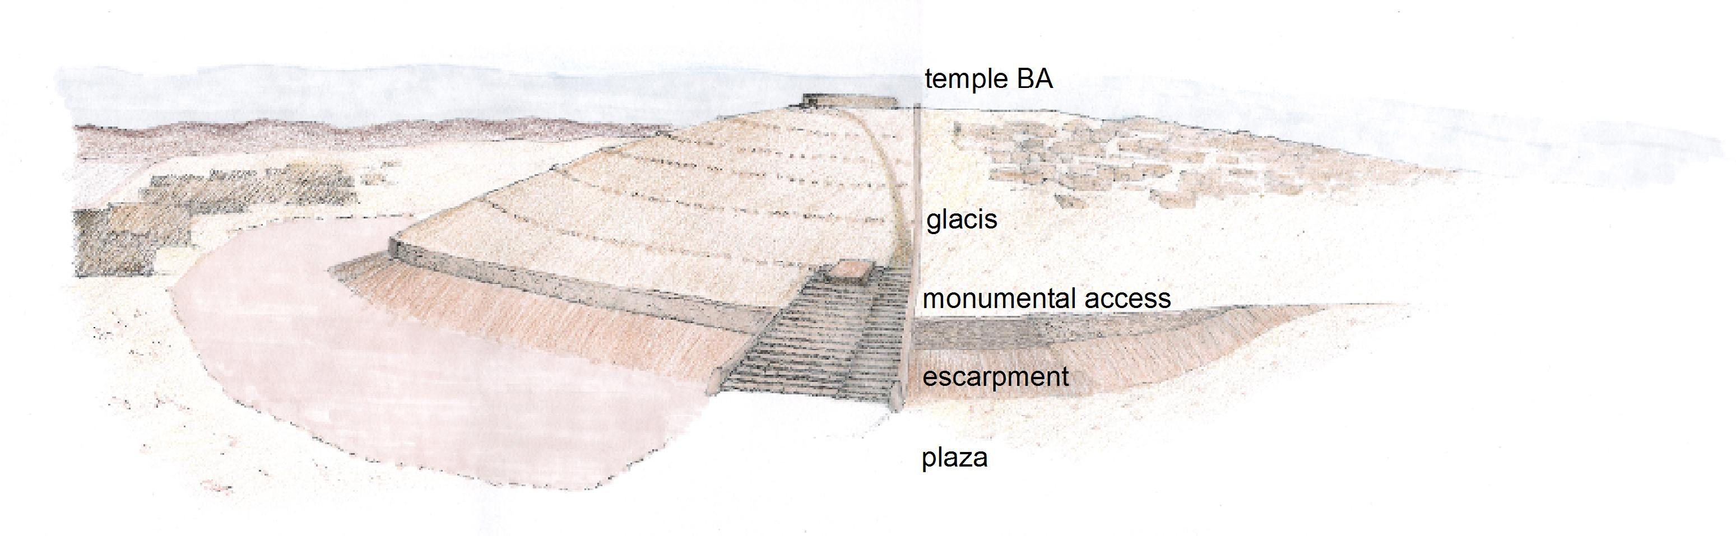

Schematic floor plan with Palace
L:\MZ-A partial\AA-BA\- general plan\2006\schematic section Py25.jpg
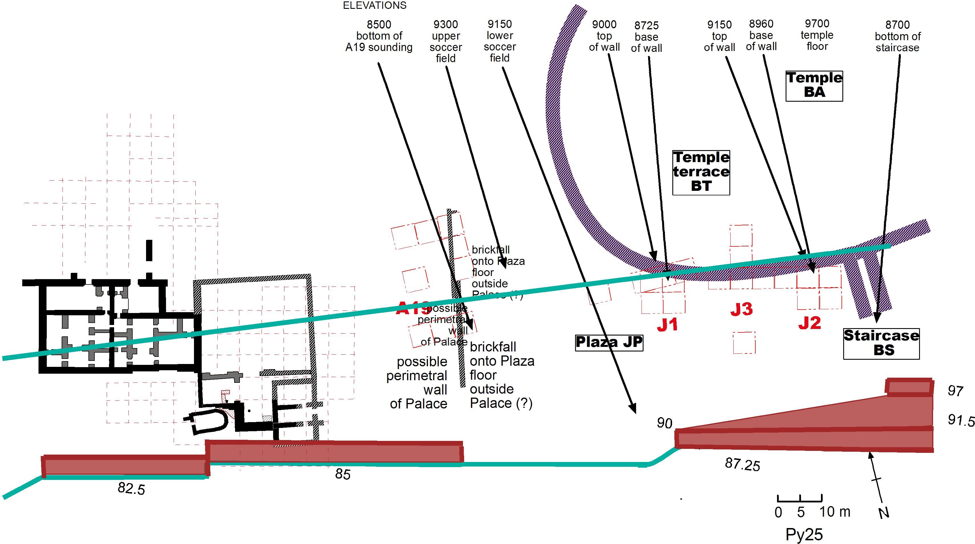

Schematic floor plan of JP alone
H:\MZ\A\JP\schematic plans\Fig. 5 revised floor plan P828.jpg
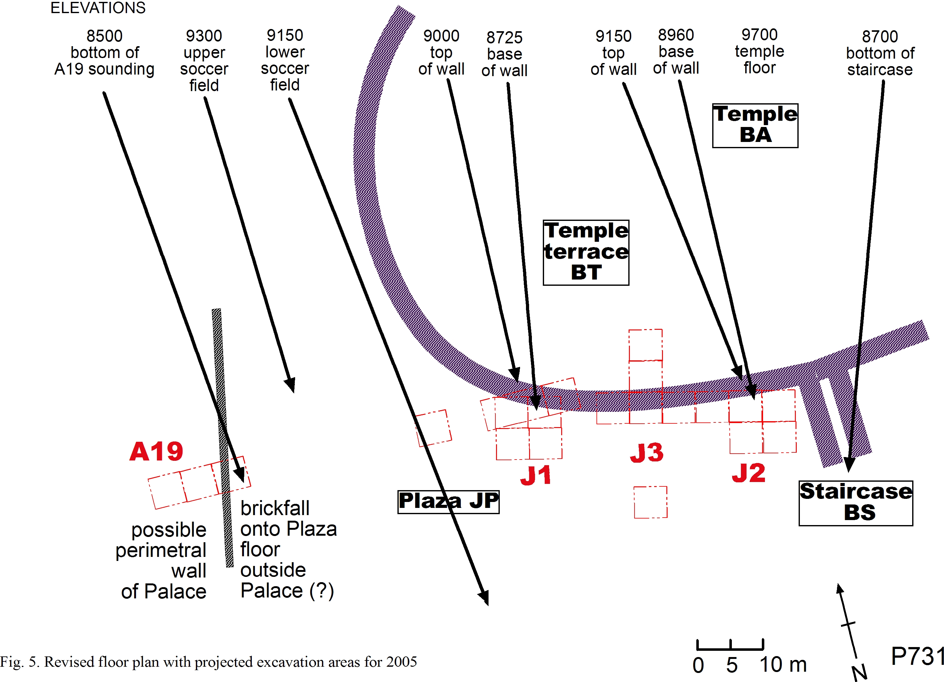

Palace and Temple Terrace (Reemes)
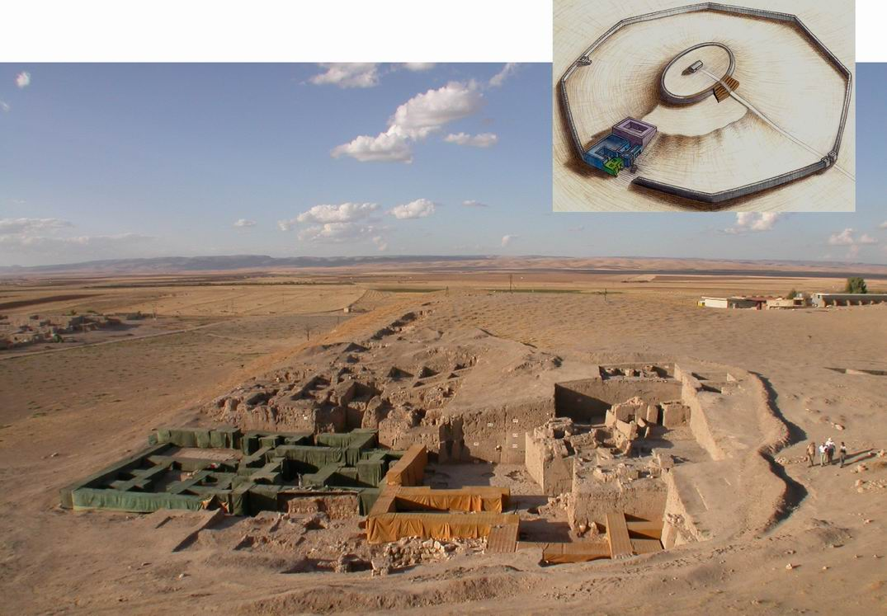
H:\MZ\A\AA-BA\- 3-D reconstr Reemes\O715-\AP-BA N618 Reemes darker with apron cropped.jpg
..\..\..\..\MZ-A partial\Y05 architecture Pesaresi 2005\gB additions\3 Resize of palace letter size.jpg

Drawing of Temple terrace with photos
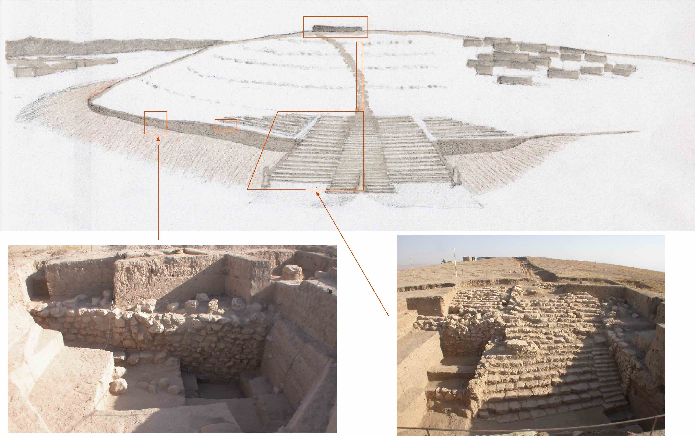
..\..\..\..\MZ-A partial\Y05 architecture Pesaresi 2005\gB additions\2 drawing with lines plus photos letter size small.jpg

Schematic section of Terrace only
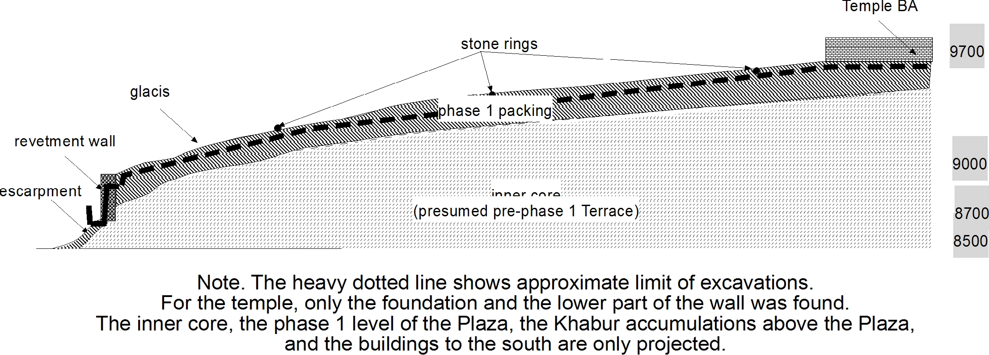
schematic of Terrace only.jpg

Schematic section of Plaza and Terrace
schemati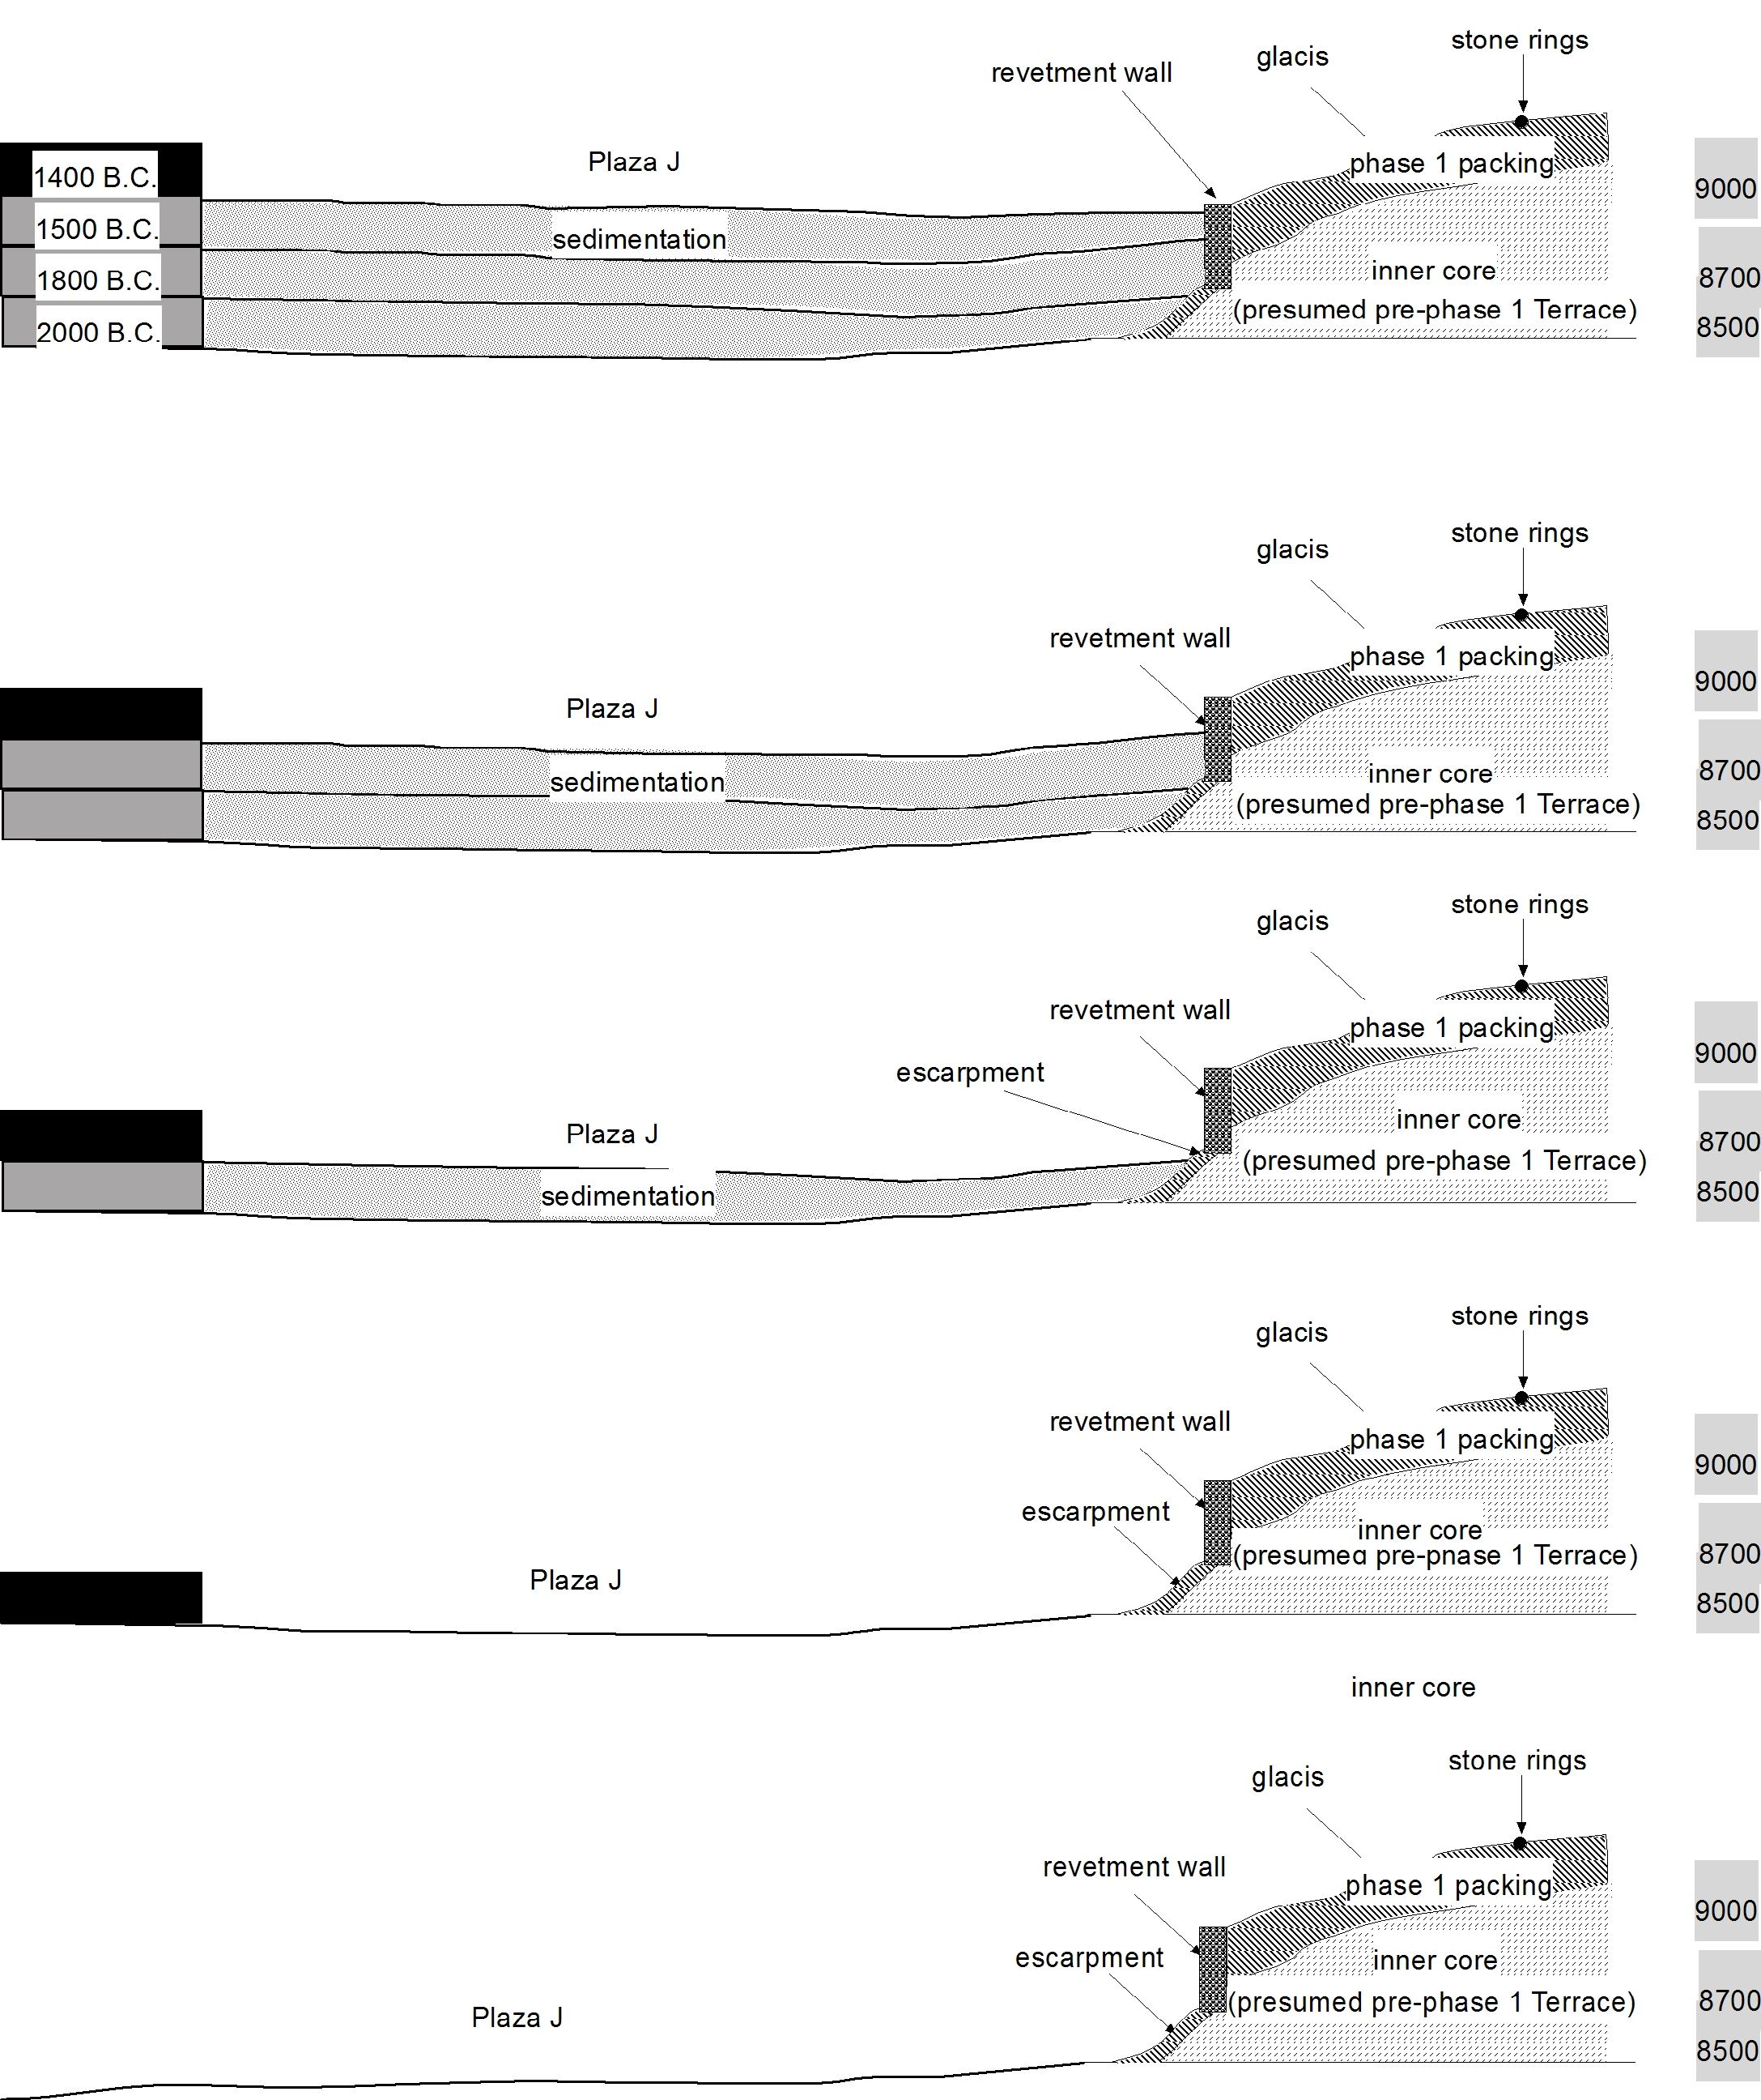c of Terrace and Plaza.jpg

Reconstruction of Temple Terrace as projected (P. Pesaresi)
L:\MZ-A partial\Y05 architecture Pesaresi 2005\Pz\tav a piccola.jpg"

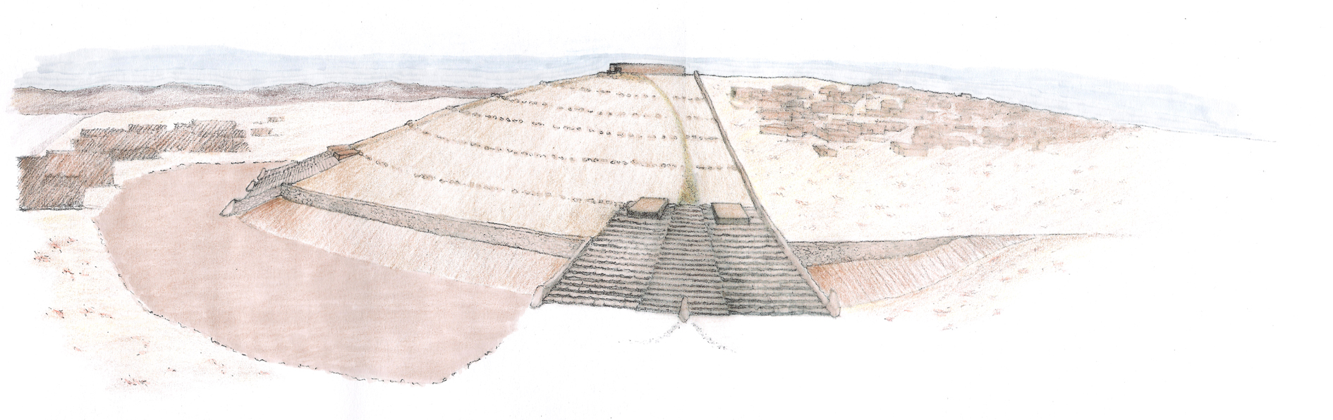
fAB 3-D reconstruction

Ideological landscapes
H:\MZ\A\W99\gb misc graphics (except tg)\region\mythical ladscapes\mythical landscapes Q212 1708 BW black at boundary.jpg

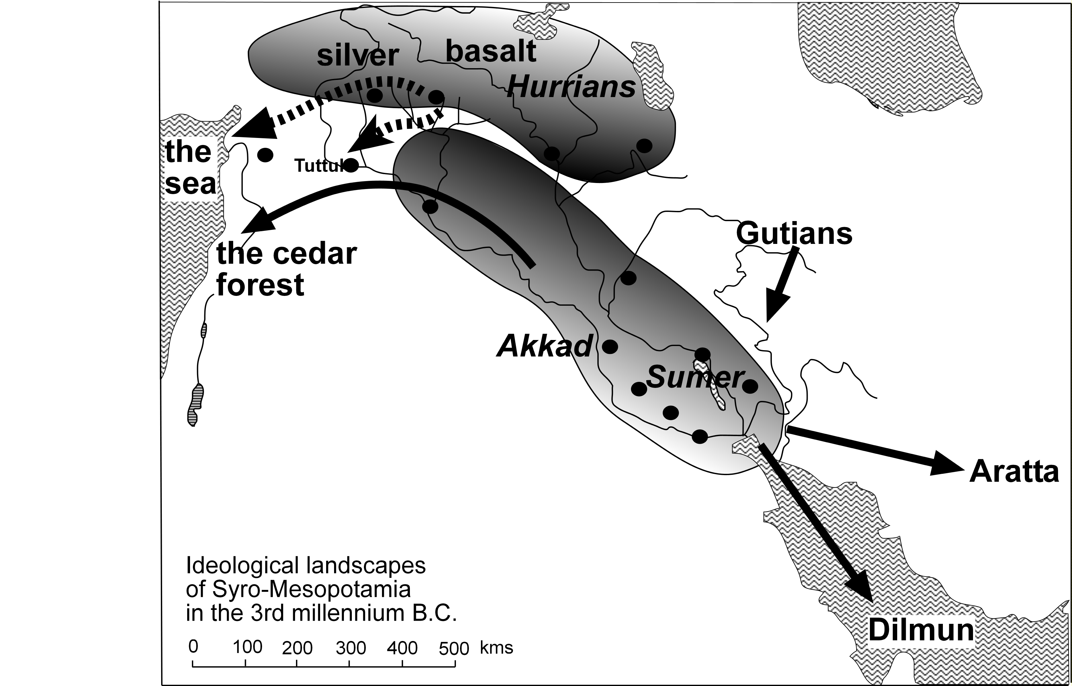

Photographic Illustrations

Overall view of 2005 excavations with gB template
..\..\..\..\MZ-A partial\VW18\J3\P913 plaza.jpg

J2 overall view with gB template
..\..\..\..\MZ-A partial\VW18\J2\J2 Building phases.jpg

J2 final view from SW
..\..\..\..\MZ-A partial\VW18\J2\VDP911 gG 0711 011 J2v144a.jpg

J1 final view with gB template
..\..\..\..\MZ-A partial\VW18\J1\L_ P913.jpg

J3 final view with gB template
..\..\..\..\MZ-A partial\VW18\J3\L_ P913.jpg

J3q47.1: ceramic boar or pig
Ill.6-8 objects.jpg

J1.16: cylinder seal
Ill.6-8 objects.jpg

J2q423.1: Mittani sherd
Ill.6-8 objects.jpg

The 18th Season of Excavations at Tell Mozan 1
for SCCNH (Owen Volume) – December 2005 1
Giorgio Buccellati and Marilyn Kelly-Buccellati 1
1 The Temple and its Terrace 1
1.1 The main goals 1
1.2 History of the research 2
1.3 The 2005 season 3
1.4 Development and structural components 4
2 Stratigraphy 5
2.1 Strategy 5
2.2 Phase assignments: synopsis 6
2.3 Evidence for the period before 2400 B.C. 7
2.4 Construction of wall and staircase about 2400 B.C. 7
2.5 Structural integrity of revetment wall and glacis through 1400 B.C. 7
2.6 The gap between 2400 B.C. and 1500 B.C. 8
2.7 The re-organization of the space around 1500 B.C. 8
2.8 The second millennium inert sedimentation above the plaza 9
2.9 Scattered occupation after the end of Urkesh as sacral center 10
3 The Terrace: revetment wall, packing and glacis 10
3.1 The base of the Terrace revetment wall and its structural features 10
3.2 The escarpment at the base of the wall 11
3.3 The inside face of the Terrace revetment wall 11
3.4 The terrace packing and the glacis 12
3.5 Footings and use areas at the base of the wall 13
4 The monumental staircase 13
4.1 Structural considerations 13
4.2 The higher stages of the monumental access and the vanishing perimetral wall 14
4.3 The lower stages of the monumental access 14
4.4 Projections 15
5 The Plaza 16
5.1 The third millennium surface and the escarpment 16
5.2 The shrinking of the use areas in the Mittani period 16
5.3 The plaza as sacred space 17
5.4 Perspectives on future work 17
6 Objects and ceramics 18
6.1 Objects from the Mittani strata 18
6.2 Ceramics from the Mittani strata 19
6.3 The transition from Khabur to Mittani 19
6.4 Ceramics from the phase 1 strata 19
6.5 Chalcolithic sherds in phase 1 strata 20
6.6 A burial in A9 and a jar in K4 [OMIT ?] 20
7 The lions of Tish-atal 21
7.1 A double hypothesis about Tish-atal and Kumarbi 21
7.2 Provenance of the lions 21
7.3 Dating of the lions 22
7.4 The Temple of Kumarbi 25
7.5 The tablet of Atal-shen 25
7.6 Stylistic considerations 26
7.7 Comparative considerations 28
7.8 The question of Hurrian ethnicity 28
8 Figures 29
8.1 Reconstruction of Temple Terrace as excavated 29
8.2 Schematic floor plan with Palace 29
8.3 Schematic floor plan of JP alone 29
8.4 Palace and Temple Terrace (Reemes) 29
8.5 Drawing of Temple terrace with photos 29
8.6 Schematic section of Terrace only 29
8.7 Schematic section of Plaza and Terrace 29
8.8 Reconstruction of Temple Terrace as projected (P. Pesaresi) 30
8.9 fAB 3-D reconstruction 30
9 Photographic Illustrations 30
9.1 Overall view of 2005 excavations with gB template 30
9.2 J2 overall view with gB template 30
9.3 J2 final view from SW 30
9.4 J1 final view with gB template 30
9.5 J3 final view with gB template 30
9.6 J3q47.1: ceramic boar or pig 30
9.7 J1.16: cylinder seal 30
9.8 J2q423.1: Mittani sherd 30

MDOG
REFERENCES M1, RLA, Cotsen Vol.
SEE….; GIVE CORRELATION TO GERMAN STRATA
Elevations are in centimeters, and they correspond to a geo-referenced elevation if one adds 400 meters to each figure. In other words, 9700 corresponds to 497.00 meters above sea level. In our system, all horizontal measurements have also been geo-referenced since the beginning.
This has been discussed in SMEA
REFERENCES
REVERENCES
Dates are according to the middle chronology, though we are increasingly leaning towards accepting a lower chronology, on the basis in part of internal evidence from our excavations that we cannot discuss here.
We have already developed these ideas in SMEA
REFRENCES
An indication of these concentric circles of stones is apparent from trench B6, see Pfälzner …. MDOG
REFERENCE TO PFAELZNER…
SMEA
Pfaelzner….
We have more briefly outlined these reasons in ….
In Mesopotamian royal inscriptions of the third millennium mentioning the construction of a temple, the location where the temple is built is generally omitted. In those instances where it does occur, the location is always different from that of the capital city, see for instance the inscriptions of Naram-Sin on objects mentioning Nippur (RIME 2, p. 147f.) and Ereš (p. 149), of Šar-kali-šarri on door sockets mentioning Nippur (p.187f) and on an unknown object (we have only a Neo-Babylpnian copy) mentioning Zabala (p. 192), of Ur-nigina of Uruk on a cone found in Ur and mentioning Bad-Tibira (p. 274f.), of Ur-Nammu on bricks mentioning Eridu (RIME 3/2, p.30f.). According to the pattern, it seems plausible to assume that if a location is not mentioned, it is more likely to be the capital city – in our case, Urkesh.
Notwithstanding the objections by O. Muscarella, UMS 1, p. 96.
This information is based on our interpretation of Van Liere’s communication, to the effect that the lions were “excavated” in “Tell Amuda”: see UMS 1, p. 36.
See above, 2.2, for a synopsis of the phases used in different areas.
In UMS 3, p. 28 f., it was suggested otherwise, namely that the entrance or a corner of the Phase 2 temple (= Phase 4a of the Palace) may have been still extant in 1948, and that the lions might therefore have come from a foundation box connected with this building. The reason we are now revising our opinion is that as a result of the familiarity that we have developed during our twenty years presence at Mozan we have observed that the thick sod layer acts as an impenetrable mantle, one that does not allow erosion to take place unless and until it is removed (which in itself requires considerable effort).
This cannot be proven, but it can hardly be otherwise: they were seen at the same time on the antiquities market in Paris, they were certainly bought at the same time, and Van Liere speaks of both lions together.
References
Nougayrol ...
See, for instance, Peter M. M. Akkermans and Glenn M. Schwartz, The Archaeology of Syria. From Complex Hunter-Gatherers to Early Urban Societies (ca. 16,000-300 BC) Cambridge World Archaeology. Cambridge: University Press, 2003, who say that in the first half of the third millennium, Syria experienced “a period of ruralization,” as a result of which there developed "a landscape of small communities with little or no evidence of monumental architecture, elite art or writing" (p.210), and with "little evidence for the existence of states or urbanism" (p.216). Out of this “landscape,” Urkesh emerges as “a post-Akkadian kingdom” (p.284). We see a very different picture. Apart from the issue of the Tish-atal lions, it is certain that (a) the Temple Terraces as we have them in Mozan and Chuera date to late ED III; that (b) earlier versions of both terraces lurk under the extant remains; and that (c) such huge and distinctive monumental architecture, at such high elevation in both sites, must reflect an even earlier autonomous tradition. In our judgment, the northernmost portion of the Khabur plains is culturally very distinct from the southern portion, and the two underwent a very different historical development. Also, Jason Ur ...
See already G. Buccellati, review..; see also M. Giorgieri, “Bedeutung und Stellung der ‘mittanischen’ Kultur im Rahmen der Kulturgeschichte Vorderasiens,” n. 20. In an earlier publication, we had instead excluded the possible identification of Kumarbi, which Van Liere had proposed (but not argued), UMS 1, p. 36.
G. Wilhelm, “Die Inschrift des Tišatal von Urkeš,” in UMS 3, pp. 199-120, 140-141.
Hoffner…
Thureau-Dangin 1912, 1-4; Frayne 1997, 461f; Salvini 2000, 36-38.
Note that the phrase occurs at the beginning of the inscription (ll.1-3) in the manner of an anticipatory and emphatic extraposition, and that reference to the place name Hawalum is missing in ll. 11-12, where specific mention is made of the building initiative (bānī bīt NERGAL). Also note that the inscription of Tish-atal includes an invocation to ^{d}NIN Na-gàr^{KI} “the lady of Nagar” (l. 18).
References esp. gB Ethnicity, mKB Burney
As is being recognized more and more in the archaeological record, see for instance G. Stein, Rethinking eorld Systems. Diasporas, Colonies and Interaction in Uruk Mesopotamia, Tucson: University of Arizona Press, 1999, pp. 112-116.

